

FOR IMMEDIATE RELEASE MAY 2017
“A WORLD LIKE NOWHERE ELSE”
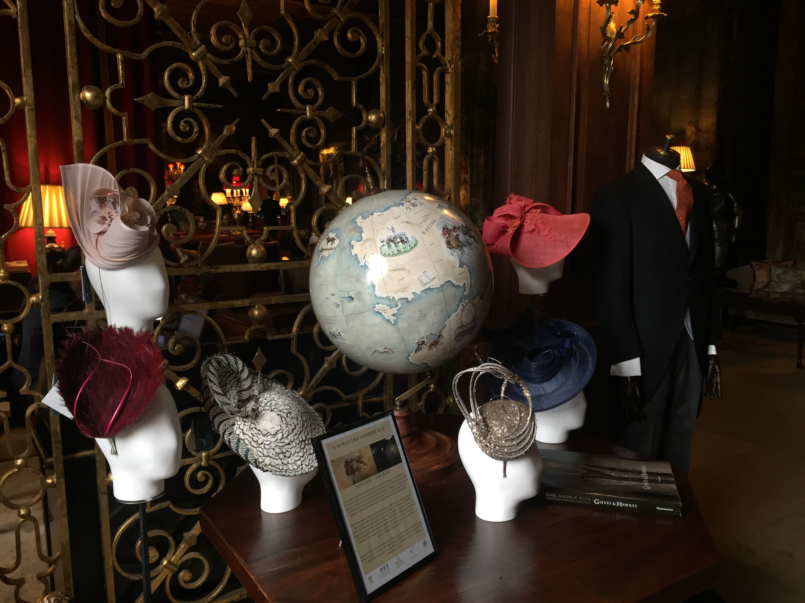
Two months ago, Royal Ascot unveiled a one-of-a-kind piece of art, a wonderful globe which tells the story of the summer’s most regal event ‘Royal Ascot’. Since that date in March, this beautiful piece of art as toured the Capital and the South East and currently is on display in the Great Hall at Cliveden House.

With Royal Ascot is just weeks away, we are delighted to display the globe entitled ‘A World Like Nowhere Else’ in the setting of this fabulous house, which has such close links to the history of Ascot, including Cliveden’s former owner, Waldorf Astor (2nd Viscount), still holding the record for the highest number of winners of Royal Ascot’s important Coronation Stakes. The horses all emanated from his three foundation mares, who likely spent time here at Cliveden and we are therefore very proud to be showcasing a piece of art that ties in perfectly with the history of this property.

Guests visiting Cliveden until the 9th June will also be able to enjoy an Ascot-themed afternoon tea in the wonderful setting of the Great Hall where the Royal Ascot Globe is on display. A welcome glass of Pimms or Bucks Fizz will be served on arrival, followed by a delicious afternoon tea including finger sandwiches, freshly baked scones with home-made jam and clotted cream, miniature delectable bite-sized cakes, pastries and delicacies, our famous Cliveden fruit cake and an Ascot inspired cake in Lord Astor’s racing colours and of course the full bodied aromatic Cliveden blend of teas.

Guests will also be able to view a beautiful exhibition of millinery on display from the award-winning British designer Vivien Sheriff with an opportunity to try on some of these fabulous creations that will be seen worn at Ascot this season, Vivien suitably impressive roster of high-end clients, includes prominent members of the British Royal Family. Male fashion will also be on display in the Great Hall with a display from Gieves & Hawkes - a bespoke men's tailor and menswear line located at 1 Savile Row, London, founded in 1771. Gieves and Hawkes is one of the oldest continual bespoke tailoring companies in the world. The company holds a number of Royal Warrants, and provides ready-to-wear as well as bespoke and military tailoring. The current creative director is Jason Basmajian, formerly of Brioni.

Following afternoon tea, guests will be able to enjoy a cruise on the river Thames aboard the vintage launch the Suzy Ann and also enter a competition to win an overnight stay at Cliveden to coincide with Ascot week in 2018. The afternoon tea experience is priced at £75 and booking is recommended.

For further press information, please contact:
Angela Day
Head of Public Relations, Iconic Luxury Hotels
Mobile: 07785 619294
Telephone: 01304 617755
E-mail: angela@iconicluxuryhotels.com
www.clivedenhouse.co.uk www.iconicluxuryhotels.com

Cliveden House is a five-star luxury hotel; the building is owned by the National Trust and operated under a long lease arrangement by the owners of Chewton Glen. Less than 45 minutes west of London and 20 minutes from London Heathrow Airport, the hotel has 47 rooms, including 9 spacious suites, a summerhouse by the Thames, together with boathouse and boats, heated pool, spa and a range of sporting and leisure facilities. The André Garrett Restaurant is complemented by the relaxed informality of The Astor Grill, together with a range of private dining, banqueting and meeting facilities. Cliveden is unique, the setting, architecture and interiors all speak eloquently of extraordinary extravagance and remarkable refinement. There is a palpable sense of history for this is a house that for over 350 years has been dedicated to the pursuit of pleasure, power and politics.

